Day 1 – Introduction to Data Analytics & Data Science

1. Task Day & Date
- Day: Friday
- Date: 11/09/2026

2. Task Description
Today's task was to learn the basics of Data Analytics and Data Science. I learned what data means and how it is used in real life. I also learned the difference between a Data Analyst and a Data Scientist. Along with this, I studied the types of analytics and the difference between structured and unstructured data. Lastly, I understood the complete data project lifecycle, from collecting data to making business decisions.

3. Task Elaboration

1. What is Data Analytics?
Data Analytics is the process of studying data to find useful information from it. It helps us understand what happened and why it happened. For example, a shop owner can look at sales data to find which product sells the most.

2. What is Data Science?
Data Science is a wider field that uses data, statistics, and machine learning to predict future results. It does not just study the past, it also tries to guess what will happen next. For example, Netflix uses data science to guess which movie a user will like next.

3. Difference Between Data Analyst and Data Scientist
Point | Data Analyst | Data Scientist
Goal | Understand past data | Predict future outcomes
Data Used | Clean, structured data | Structured and unstructured data
Tools | Excel, SQL, Power BI | Python, ML libraries, TensorFlow
Output | Reports and dashboards | Prediction models
Example Work | Sales report of last month | Predicting next month sales

4. Types of Analytics
Descriptive Analytics: It tells us what has happened in the past using data.
Diagnostic Analytics: It tells us why something happened in the past.
Predictive Analytics: It tells us what may happen in the future.
Prescriptive Analytics: It tells us what action we should take next.

5. Complete Data Science Project Lifecycle
- Business Problem: First, we understand what problem the company wants to solve.
- Data Collection: We collect data from different sources like files, websites, or databases.
- Data Cleaning: We remove errors, missing values, and duplicate data.
- Data Exploration: We study the data closely to find patterns and trends.
- Statistical Analysis: We use statistics to understand the data in a better way.
- Visualization: We show the data using charts and graphs so it is easy to understand.
- Machine Learning: We build models that can learn from data and make predictions.
- Model Evaluation: We check how accurate our model is.
- Business Decision: The company uses the results to make good decisions.
- Deployment / Reporting: The final model or report is shared and used in real work.

6. Real-World Examples
Data Analytics Example: Supermarket Sales Analysis
Imagine a supermarket collects data every day about what customers buy things like milk, bread, snacks, and vegetables. At the end of the month, the store manager wants to know which products are selling the most and which ones are just sitting on the shelves. This is where data analytics comes in.
Data Science Example: Netflix Movie Recommendations
Now think about Netflix. Every time you watch a movie or show, skip something, or pause halfway through, Netflix quietly stores that information. It also looks at what millions of other users with similar taste have watched. Using all this data, Netflix builds a smart model that learns your preferences over time

7. Technologies Used by Data Analysts
Tool | Use
Excel | Used for basic data entry and simple analysis
SQL | Used to fetch and manage data from databases
Python | Used to clean and analyse data
Power BI | Used to make dashboards and reports
Tableau | Used to create data visualizations

8. Technologies Used by Data Scientists
Tool | Use
Python | Main language used for data science work
Pandas | Used to handle and analyse data tables
NumPy | Used for numerical and array calculations
Scikit-learn | Used to build machine learning models
TensorFlow | Used to build deep learning models

Day 2 – Python Basics

1. Task Day & Date
- Day : Friday
- Date: 11/09/2026

2. Task Description
Today's task was to learn the basics of Python programming. I learned about variables, data types, strings, numbers, and boolean values. I also learned about lists, tuples, sets, and dictionaries. Along with this, I studied operators, conditions, and loops. After learning these topics, I wrote small Python programs to practice what I learned.

3. Task Elaboration

# 1. Calculator
"""
num1 = float(input("Enter first number: "))
num2 = float(input("Enter second number: "))
print("1. Addition")
print("2. Subtraction")
print("3. Multiplication")
print("4. Division")
choice = int(input("Enter your choice: "))
if choice == 1:
print("Addition =", num1 + num2)
elif choice == 2:
print("Subtraction =", num1 - num2)
elif choice == 3:
print("Multiplication =", num1 * num2)
elif choice == 4:
if num2 != 0:
print("Division =", num1 / num2)
else:
print("Cannot divide by zero")
else:
print("Invalid choice")

# 2. Even/odd number
num = int(input("Enter Number: "))
if num%2 == 0:
print("Even Number")
else:
print("Odd Number")

# 3. Positive/negative number
num = int(input("Enter a number:"))
if num >=0:
print("This number is positive")
else:
print("This number is negative")

# 4. Largest of 3 numbers
a=int(input("Enter Number: "))
b=int(input("Enter Number: "))
c=int(input("Enter Number: "))
if a>b and a>c:
print(a,"is largest")
elif b>c:
print(b,"is largest")
else:
print(c,"is largest")

# 5. Student grade calculator
marks=int(input("Enter Marks:"))
if marks>=90 and marks<=100:
print("Grade A")
elif marks>=70 and marks<90:
print("Grade B")
elif marks>=60 and marks<70:
print("Grade C")
elif marks>=35 and marks<60:
print("Grade D")
else:
print("Fail")

# 6. Multiplication table
num=int(input("Enter Number: "))
for i in range(1,11):
print(num,"X",i,num*i)

# 7. Factorial
fact=1
n=int(input("Enter a number:"))
for i in range(1,n+1):
fact*=i
print(fact)

# 8. Fibonacci series
a=0
b=1
print(a)
print(b)
for i in range(2,11):
c=a+b
a=b
b=c
print(c)
"""
# 9. Count vowels
a=str(input("Enter String: "))
vowels=0
for i in a:
if i =="a" or i =="e" or i =="i" or i == "o" or i =="u"or i =="A"or i =="E"or i =="I"or i =="O"or i =="U":
vowels+=1
print("vowels count",vowels)

# 10. Reverse a string
a=str(input("Enter String: "))
print(a[::-1])

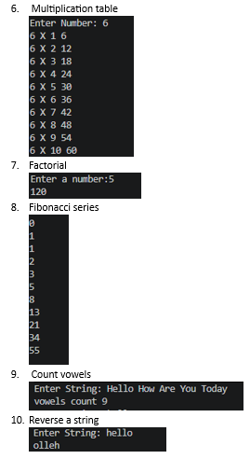
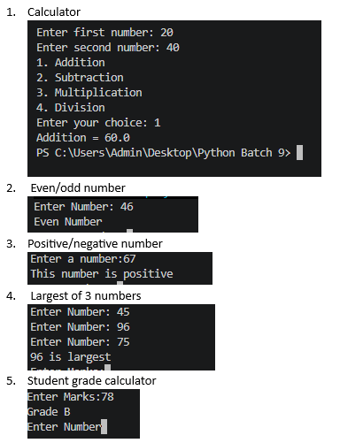
4. Task Screenshot / Proof

Day 3 – Functions & Advanced Python Basics

1. Task Day & Date
- Day: saturday
- Date: 12/09/2026

2. Task Description
Today's task was to learn about functions in Python. I learned how to create functions, pass values to them using parameters, and get results back using return values. I also learned about lambda functions, map(), filter(), list comprehension, dictionary comprehension, exception handling, and modules. After learning these topics, I created a few functions and used them together in one program.

3. Task Elaboration
# Functions in Python (Basic)
def calculate_average(a, b, c):
avg = (a + b + c) / 3
return avg
def calculate_max(a, b, c):
if a >= b and a >= c:
return a
elif b >= a and b >= c:
return b
else:
return c
def calculate_min(a, b, c):
if a <= b and a <= c:
return a
elif b <= a and b <= c:
return b
else:
return c
def calculate_percentage(total):
percentage = (total / 300) * 100
return percentage
def calculate_grade(percentage):
if percentage >= 90:
return "A+"
elif percentage >= 75:
return "A"
elif percentage >= 60:
return "B"
elif percentage >= 40:
return "C"
else:
return "Fail"
# Main Program
print("Student Result Calculator")
m1 = int(input("Enter marks of Subject 1: "))
m2 = int(input("Enter marks of Subject 2: "))
m3 = int(input("Enter marks of Subject 3: "))
total = m1 + m2 + m3
average = calculate_average(m1, m2, m3)
highest = calculate_max(m1, m2, m3)
lowest = calculate_min(m1, m2, m3)
percentage = calculate_percentage(total)
grade = calculate_grade(percentage)
print("\n----- Result -----")
print("Total Marks :", total)
print("Average :", average)
print("Highest Marks :", highest)
print("Lowest Marks :", lowest)
print("Percentage :", percentage)
print("Grade :", grade)

4. Task Screenshot / Proof

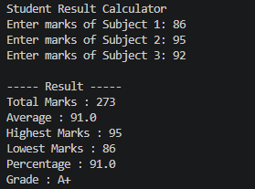

Day 4 – NumPy

1. Task Day & Date
- Day: Tuesday
- Date: 15/09/2026

2. Task Description
Today's task was to learn NumPy, which is a Python library used for working with numbers and arrays. I learned about arrays, dimensions, shape, indexing, slicing, and reshaping. I also learned how to perform arithmetic operations and find aggregations like mean, median, and standard deviation. I practiced all of this using a NumPy array of sales data.

3. Task Elaboration
import numpy as np

# 1D Array (Sales Data)
sales = np.array([1200, 1500, 1800, 2000, 1700])

print("Sales Data:", sales)

# Sales Calculations
print("Total Sales:", np.sum(sales))
print("Average Sales:", np.mean(sales))
print("Maximum Sales:", np.max(sales))
print("Minimum Sales:", np.min(sales))
print("Standard Deviation:", np.std(sales))
print("Median:", np.median(sales))
print("25th Percentile:", np.percentile(sales, 25))
print("75th Percentile:", np.percentile(sales, 75))

# 2D Array
array2d = np.array([[1, 2, 3],
[4, 5, 6]])

print("\n2D Array:")
print(array2d)

# Reshaping
reshape_array = np.arange(1, 13).reshape(3, 4)

print("\nReshaped Array:")
print(reshape_array)

# Matrix Multiplication
A = np.array([[1, 2],
[3, 4]])

B = np.array([[5, 6],
[7, 8]])

C = np.matmul(A, B)

print("\nMatrix Multiplication:")
print(C)

4. Task Screenshot / Proof
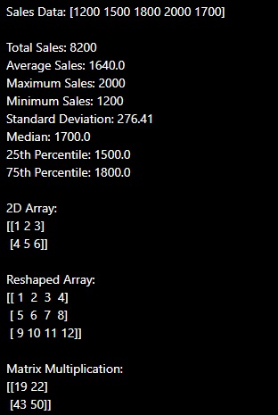

Day 5 – Pandas Basics

1. Task Day & Date
- Day: Wednesday
- Date: 16/09/2026

2. Task Description
Today's task was to learn Pandas, which is a Python library used to work with data in table form. I learned about Series and DataFrame, and how to load a dataset using read_csv(). I also learned how to check the first and last rows, the number of rows and columns, data types, missing values, and summary statistics of a dataset.

3. Task Elaboration
import pandas as pd

# 1. Load dataset
df = pd.read_csv("sales_data.csv")

# 2. Display first 10 rows
print("First 10 Rows")
print(df.head(10))

# 3. Display last 10 rows
print("\nLast 10 Rows")
print(df.tail(10))

# 4. Find number of rows
print("\nNumber of Rows:", df.shape[0])

# 5. Find number of columns
print("Number of Columns:", df.shape[1])

# 6. Check data types
print("\nData Types")
print(df.dtypes)

# 7. Find missing values
print("\nMissing Values")
print(df.isnull().sum())

# 8. Generate summary statistics
print("\nSummary Statistics")
print(df.describe())

4. Task Screenshot / Proof

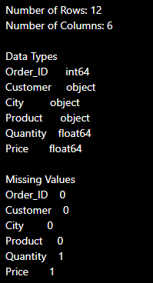

Day 6 – Data Cleaning

1. Task Day & Date
- Day: Thursday
- Date: 17/09/2026

2. Task Description
Today's task was to learn how to clean dirty data. I learned how to find missing values, duplicate rows, wrong data types, incorrect values, inconsistent text, and outliers. I took a dirty dataset and cleaned it step by step so that it became ready to use.

3. Task Elaboration
import pandas as pd

df = pd.read_csv("dirty_employee_data.csv")
print(df.isnull().sum())
print(df.duplicated().sum())
print(df.dtypes)
df["Age"] = df["Age"].astype(str).str.replace(r"[^0-9]", "", regex=True)
df["Age"] = df["Age"].replace("", pd.NA)
df["Age"] = df["Age"].astype(float)
df["Salary"] = df["Salary"].astype(str).str.replace(r"[^\d.\-]", "", regex=True)
df["Salary"] = df["Salary"].replace("", pd.NA)
df["Salary"] = df["Salary"].astype(float)
df["Department"] = df["Department"].str.strip().str.lower()
df["Country"] = df["Country"].str.strip().str.lower()
country_map = {
"usa": "USA",
"united states": "USA",
"india": "India",
}
df["Country"] = df["Country"].map(country_map)
df = df.drop_duplicates(subset=["Name", "Email"], keep="first")
# A number column: fill gaps with the median (the "typical" middle value)
df["Age"] = df["Age"].fillna(df["Age"].median())
df["Salary"] = df["Salary"].fillna(df["Salary"].median())

# A text column where guessing a value is misleading: use a clear placeholder
df["Email"] = df["Email"].fillna("unknown@company.com")
age_outliers = df[(df["Age"] < 18) | (df["Age"] > 65)]
salary_outliers = df[(df["Salary"] < 0) | (df["Salary"] > 500000)]

print(age_outliers[["EmployeeID", "Name", "Age"]])
print(salary_outliers[["EmployeeID", "Name", "Salary"]])
valid_median_age = df.loc[(df["Age"] >= 18) & (df["Age"] <= 65), "Age"].median()
df.loc[(df["Age"] < 18) | (df["Age"] > 65), "Age"] = valid_median_age
df.to_csv("cleaned_employee_data.csv", index=False)

4. Task Screenshot / Proof

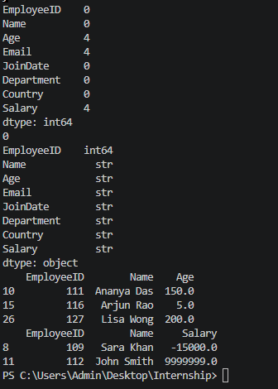
Day 7 – SQL & Database

1. Task Day & Date
- Day: Friday
- Date:18/09/2026

2. Task Description
Today's task was to create a small database with three tables: customers, products, and orders. After creating the database, I wrote more than 20 SQL queries to practice fetching, filtering, and calculating data. These queries covered simple searches, conditions, sorting, and calculations like total sales and average order value.

3. Task Elaboration

1. Create Tables & Insert Sample Data
Before writing the SELECT queries, I first created the three tables using CREATE TABLE and then added some sample rows into each table using INSERT INTO. This sample data is what my SELECT queries later run on
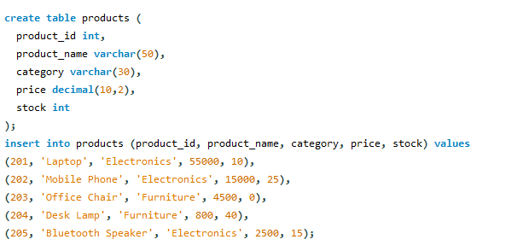

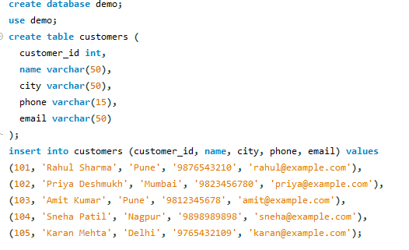

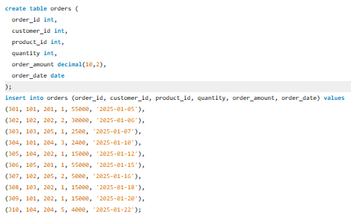

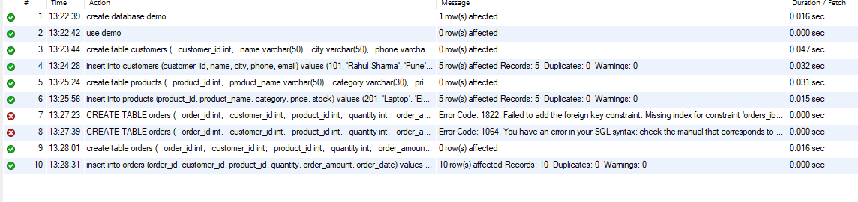

4. Task Screenshot / Proof

SQL Queries I Wrote
Below are the 20 SQL queries I wrote and ran. Each query has a short line telling what it does, followed by the query itself.
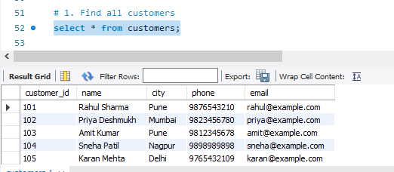

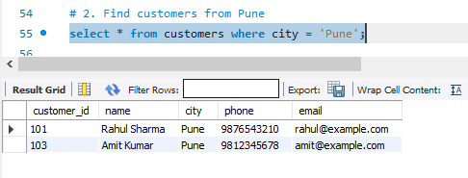

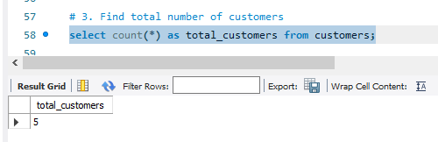

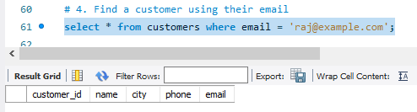

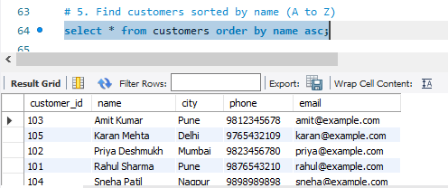

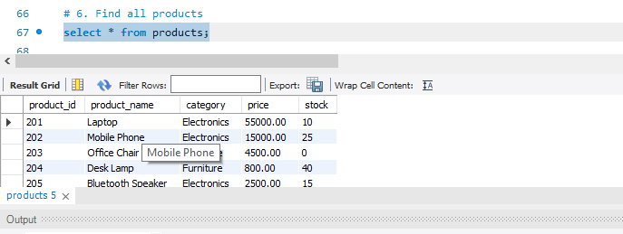

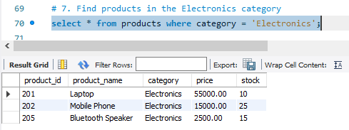

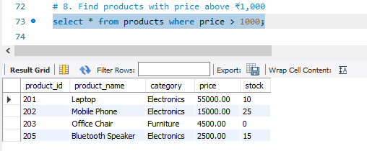

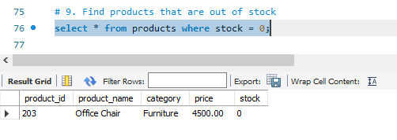

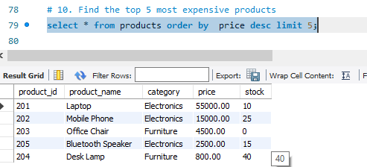

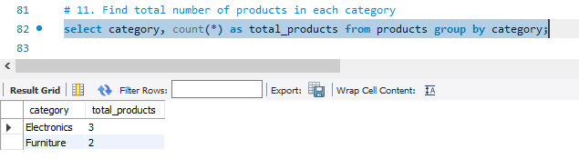
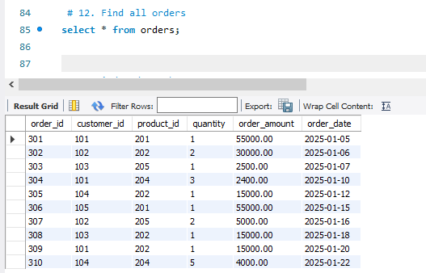

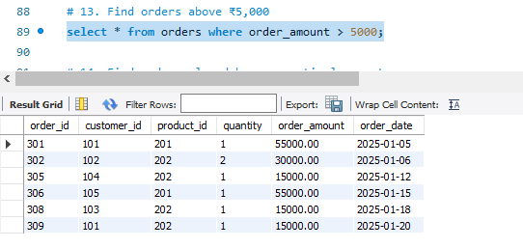

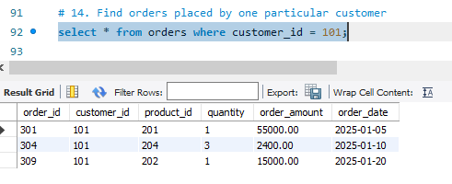

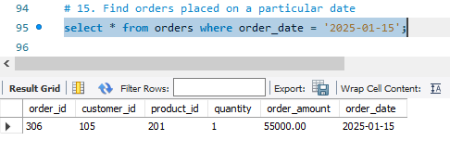
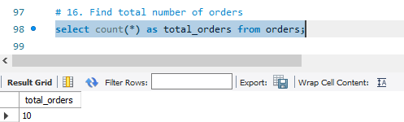

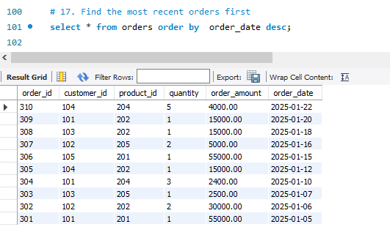

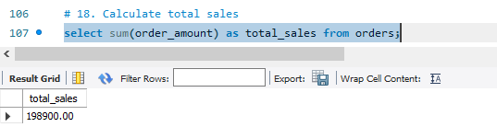

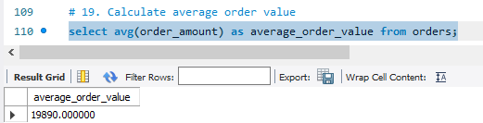

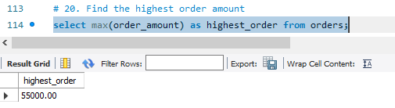

Day 8 – Advanced SQL

1. Task Day & Date
- Day: Saturday
- Date: 19/09/2026

2. Task Description
Today's task was to learn advanced SQL concepts like JOIN, INNER JOIN, LEFT JOIN, Subquery, CTE, and Window Functions. I learned window functions such as ROW_NUMBER(), RANK(), DENSE_RANK(), LAG(), and LEAD() in detail. Using these concepts, I solved real business problems like finding top customers, top products, customer ranking, monthly revenue, revenue growth, and employee salary ranking. I wrote more than 20 advanced SQL queries to practice all of this.

3. Task Elaboration
A) Problem 1 – Top 3 Customers
- Top 3 customers by total spending, using RANK()
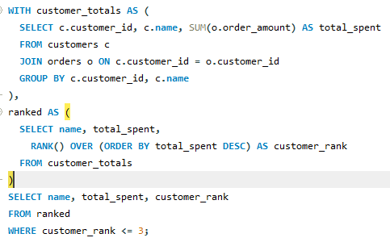

B) Problem 2 – Top 3 Products per Category

- Top 3 most expensive products in each category, using ROW_NUMBER()
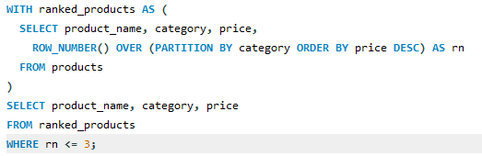

C) Problem 3 – Customer Ranking
- Rank all customers by their total spending, using RANK()
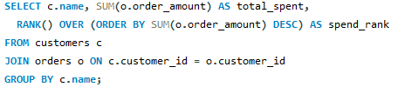
D) Problem 4 – Monthly Revenue
- Find total revenue earned in each month
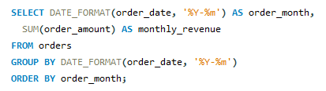
E) Problem 5 – Previous Month's Revenue
- Show each month's revenue next to the previous month's revenue, using LAG()
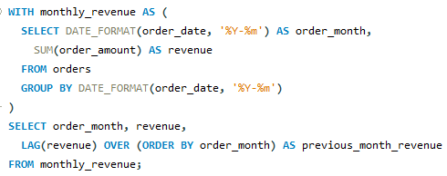
F) Problem 6 – Month-over-Month Growth
- Calculate month-over-month revenue growth percentage
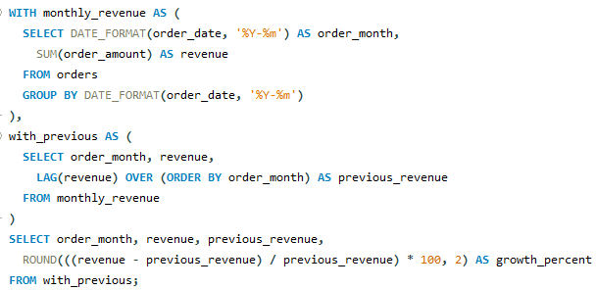
G) Problem 7 – Employee Salary Ranking
- Rank employees by salary, using RANK()
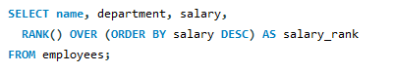
- Rank employees by salary, using DENSE_RANK()
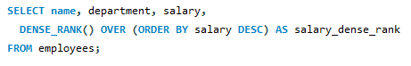
- Rank employees by salary within their own department
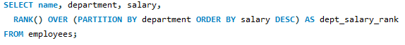

4. Task Screenshot / Proof
Problem 1
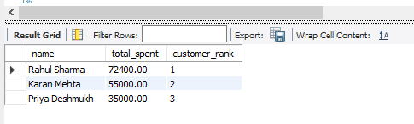
Problem 2
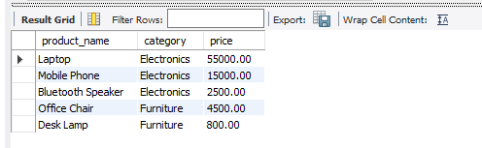

Problem 3
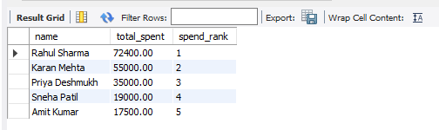
Problem 4
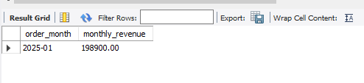
Problem 5
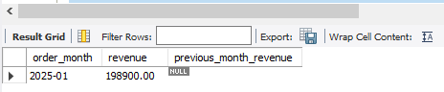

Problem 6

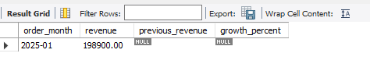
Problem 7.1
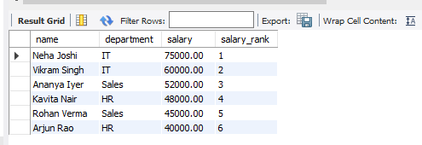

Problem 7.2
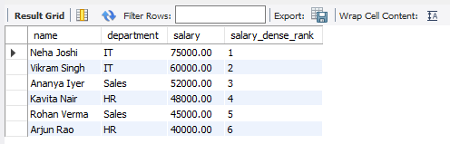

Problem 7.3

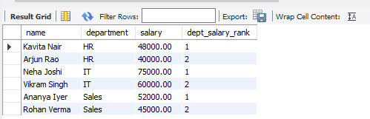

Day 9 – Statistics

1. Task Day & Date
- Day: Monday
- Date: 21/09/2026

2. Task Description
Today's task was to learn basic statistics. I learned about mean, median, mode, range, variance, standard deviation, percentile, quartile, IQR, correlation, and covariance. I took a small dataset of student marks and calculated all of these values using Python. After calculating each value, I explained what it means and why it is useful, instead of just calculating numbers without understanding them.

3. Task Elaboration
import pandas as pd
import numpy as np

data = {
"Hours_Studied":[1,2,3,4,5,6,7,8,9,10],
"Marks":[35,40,50,55,65,70,75,85,90,95]
}

df = pd.DataFrame(data)
df
mean = df["Marks"].mean()

median = df["Marks"].median()

mode = df["Marks"].mode()

range_value = df["Marks"].max() - df["Marks"].min()

variance = df["Marks"].var()

std = df["Marks"].std()

q1 = df["Marks"].quantile(0.25)

q2 = df["Marks"].quantile(0.50)

q3 = df["Marks"].quantile(0.75)

iqr = q3 - q1

p90 = df["Marks"].quantile(0.90)

correlation = df["Hours_Studied"].corr(df["Marks"])

covariance = df["Hours_Studied"].cov(df["Marks"])

print("Mean:", mean)
print("Median:", median)
print("Mode:", mode.values)
print("Range:", range_value)
print("Variance:", variance)
print("Standard Deviation:", std)
print("Q1:", q1)
print("Q2:", q2)
print("Q3:", q3)
print("IQR:", iqr)
print("90th Percentile:", p90)
print("Correlation:", correlation)
print("Covariance:", covariance)

Explanation
1. Mean (Average)
Value: 66.0
The average marks of all students is 66. Mean represents the central value of the dataset.
2. Median
Value: 67.5
Median is the middle value after sorting. It is useful because it is less affected by extreme values.
3. Mode
Value: No mode
Every mark appears only once, so there is no most frequent value.
4. Range
Formula: Highest − Lowest
95 − 35 = 60
The marks are spread across 60 points.
5. Variance
Variance measures how far values are spread from the mean. Higher variance means greater variability.
6. Standard Deviation
Standard deviation is the square root of variance and tells the average distance from the mean. Lower SD means more consistent data.
7. Percentile
90th Percentile ≈ 90.5
It means 90% of students scored below about 90.5 marks.
8. Quartiles
- Q1: 51.25
- Q2: 67.5
- Q3: 82.5
Quartiles divide data into four equal parts.
9. IQR (Interquartile Range)
Formula: Q3 − Q1
82.5 − 51.25 = 31.25
IQR shows the spread of the middle 50% of the data and helps detect outliers.
10. Correlation
Correlation measures the strength and direction of the relationship between Hours Studied and Marks.
Here it is close to +1, indicating a strong positive relationship.
11. Covariance
Covariance also measures how two variables move together.
- Positive → Both increase together
- Negative → One increases, the other decreases
Here it is positive, so more study hours generally lead to higher marks.

4. Task Screenshot / Proof

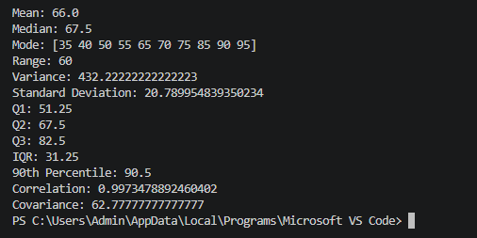

Day 10 – Probability

1. Task Day & Date
- Day: Wednesday
- Date: 23/09/2026

2. Task Description
Today's task was to learn probability. I learned about basic probability, conditional probability, independent events, dependent events, Bayes theorem, normal distribution, and binomial distribution. I solved 15 probability problems using these ideas, and then I picked 5 of them and solved them again using Python to check my answers. Probability is important because it is the base on which machine learning is built.

3. Task Elaboration
A) Basic Probability
1. What is the probability of getting a head when a fair coin is tossed once?
A coin has 2 sides, and only 1 of them is a head.
Probability = Favourable outcomes / Total outcomes = 1 / 2
Answer: 0.5 (50%)
2. What is the probability of getting an even number when a fair die is rolled?
A die has 6 numbers: 1, 2, 3, 4, 5, 6. Even numbers are 2, 4, 6, which is 3 numbers.
Probability = 3 / 6
Answer: 0.5 (50%)
3. What is the probability of drawing a red card from a normal deck of 52 cards?
A deck has 52 cards, and 26 of them are red (hearts and diamonds).
Probability = 26 / 52
Answer: 0.5 (50%)
B) Conditional Probability
4. A card is picked and it is a face card (King, Queen or Jack). What is the probability that it is a King?
There are 12 face cards in total (4 Kings, 4 Queens, 4 Jacks), and 4 of them are Kings.
P(King | Face Card) = 4 / 12
Answer: 0.333 (about 33.3%)
5. On 40% of days it is cloudy. On 20% of all days it is both cloudy and rainy. What is the probability that it rains, given that it is cloudy?
P(Cloudy) = 0.4, and P(Rain and Cloudy) = 0.2
P(Rain | Cloudy) = P(Rain and Cloudy) / P(Cloudy) = 0.2 / 0.4
Answer: 0.5 (50%)
C) Independent Events
6. A coin is tossed twice. What is the probability of getting heads both times?
The two tosses do not affect each other, so they are independent events.
P(Head and Head) = P(Head) x P(Head) = 0.5 x 0.5
Answer: 0.25 (25%)
7. What is the probability of rolling a 6 on a die and separately drawing an Ace from a deck of cards?
These two events do not affect each other.
P(6) = 1/6, P(Ace) = 4/52
P(6 and Ace) = (1/6) x (4/52)
Answer: 0.0128 (about 1.28%)
D) Dependent Events
8. Two cards are drawn one after another from a deck, without putting the first card back. What is the probability that both cards are Aces?
There are 4 Aces out of 52 cards for the first draw.
After removing 1 Ace, there are 3 Aces left out of 51 cards for the second draw.
P(Both Aces) = (4/52) x (3/51)
Answer: 0.0045 (about 0.45%)
9. A bag has 5 red balls and 5 blue balls. Two balls are picked one after another, without putting the first one back. What is the probability that both balls are red?
First pick: 5 red balls out of 10 total balls.
Second pick: 4 red balls left out of 9 total balls.
P(Both Red) = (5/10) x (4/9)
Answer: 0.222 (about 22.2%)
E) Bayes Theorem
10. A disease affects 1% of people. A test for the disease is 99% accurate for people who have it, but also gives a false positive 5% of the time for people who do not have it. If a person tests positive, what is the probability that they actually have the disease?
P(Disease) = 0.01, P(Positive | Disease) = 0.99, P(Positive | No Disease) = 0.05, P(No Disease) = 0.99
P(Positive) = (0.99 x 0.01) + (0.05 x 0.99) = 0.0594
P(Disease | Positive) = (0.99 x 0.01) / 0.0594
Answer: 0.167 (about 16.7%)
11. 40% of emails are spam. The word "free" appears in 60% of spam emails and only 10% of normal emails. If an email contains the word "free", what is the probability that it is spam?
P(Spam) = 0.4, P("free" | Spam) = 0.6, P("free" | Not Spam) = 0.1, P(Not Spam) = 0.6
P("free") = (0.6 x 0.4) + (0.1 x 0.6) = 0.30
P(Spam | "free") = (0.6 x 0.4) / 0.30
Answer: 0.8 (80%)
F) Normal Distribution
12. In a normal distribution, what is the probability that a value falls within 1 standard deviation of the mean?
This is a well-known rule for the normal distribution curve, called the 68-95-99.7 rule.
About 68% of all values fall within 1 standard deviation on either side of the mean.
Answer: 0.683 (about 68.3%)
13. Student marks are normally distributed with a mean of 70 and a standard deviation of 10. What is the probability that a student scores above 85?
First find the z-score: z = (85 - 70) / 10 = 1.5
A z-score table tells us that the area below z = 1.5 is about 0.933.
P(X > 85) = 1 - 0.933
Answer: 0.067 (about 6.7%)
G) Binomial Distribution
14. A coin is tossed 5 times. What is the probability of getting exactly 3 heads?
Here n = 5 tosses, p = 0.5 (probability of a head), and we want exactly k = 3 heads.
P(X = 3) = C(5,3) x (0.5)^3 x (0.5)^2 = 10 x 0.125 x 0.25
Answer: 0.3125 (about 31.25%)
15. A basketball player has a 30% chance of scoring on each free throw. If they take 10 free throws, what is the probability that they score exactly 2 times?
Here n = 10 throws, p = 0.3 (probability of scoring), and we want exactly k = 2 successes.
P(X = 2) = C(10,2) x (0.3)^2 x (0.7)^8 = 45 x 0.09 x 0.05765
Answer: 0.2335 (about 23.35%)

Explanation section
- Probability
Probability tells the chance that an event will happen.
Example: 5 females out of 10 students → 0.5.
- Conditional Probability
It calculates probability after another event is already known.
Example: Probability of Female given CSE = 1.0.
- Independent Event
One event does not affect another.
Example: Coin toss and dice roll.
- Dependent Event
First event changes the next event.
Example: Drawing cards without replacement.
- Bayes Theorem
Bayes updates probability using new evidence.
Used in spam filtering and medical diagnosis.
- Normal Distribution
Data follows a bell-shaped curve around the mean.
Z-score tells how far a value is from average.
- Binomial Distribution
Used when there are repeated success/failure experiments.
Example: Coin tosses.

#Day 10
import pandas as pd
import numpy as np
from scipy.stats import binom, norm

data = {
"Student":["A","B","C","D","E","F","G","H","I","J"],
"Gender":["F","M","F","M","F","M","F","M","F","M"],
"Hours":[2,3,4,5,6,4,7,8,9,10],
"Attendance":[75,80,82,85,88,78,90,92,95,97],
"Marks":[45,52,60,66,72,58,80,86,91,96],
"Department":["CSE","IT","CSE","ECE","CSE","IT","CSE","ECE","CSE","IT"]
}

df = pd.DataFrame(data)
df
# 1. Probability of Female
female = len(df[df["Gender"]=="F"])
total = len(df)

print(female/total)

# 2. Conditional Probability
cse = df[df["Department"]=="CSE"]
female_cse = len(cse[cse["Gender"]=="F"])

print(female_cse/len(cse))

# 3. Independent Event
coin = 1/2
dice = 1/6

print(coin*dice)

# 4. Binomial Distribution
from scipy.stats import binom

print(binom.pmf(3,5,0.5))

print(binom.pmf(3,5,0.5))

# 5. Normal Distribution
mean = 70
std = 10
score = 91

z = (score-mean)/std
print(z)

4. Task Screenshot / Proof

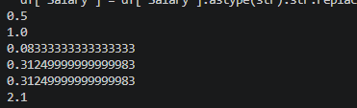

Day 11 – Matplotlib

1. Task Day & Date
- Day:
- Date:24/09/2026

2. Task Description
Today's task was to learn Matplotlib, which is a Python library used to draw charts and graphs. I learned about line charts, bar charts, histograms, scatter plots, pie charts, box plots, and area charts. Using one dataset of retail sales, I created 10 charts in total. Every chart has a title, labelled X-axis and Y-axis, and a short interpretation explaining what the chart tells us, because a chart should communicate information and not just look nice.

3. Task Elaboration

#Day 11
import pandas as pd
import matplotlib.pyplot as plt

data = {
"Student": ["A", "B", "C", "D", "E", "F", "G", "H", "I", "J"],
"Gender": ["F", "M", "F", "M", "F", "M", "F", "M", "F", "M"],
"Hours": [2, 3, 4, 5, 6, 4, 7, 8, 9, 10],
"Attendance": [75, 80, 82, 85, 88, 78, 90, 92, 95, 97],
"Marks": [45, 52, 60, 66, 72, 58, 80, 86, 91, 96],
"Department": ["CSE", "IT", "CSE", "ECE", "CSE", "IT", "CSE", "ECE", "CSE", "IT"]
}

df = pd.DataFrame(data)

print(df)
# 1. Line Chart
plt.figure(figsize=(6,4))
plt.plot(df["Hours"],df["Marks"],marker="o")
plt.title("Hours Studied vs Marks")
plt.xlabel("Hours Studied")
plt.ylabel("Marks")
plt.grid()
plt.show()

# 2. Bar Chart
dept = df.groupby("Department")["Marks"].mean()

plt.bar(dept.index,dept.values)
plt.title("Average Marks by Department")
plt.xlabel("Department")
plt.ylabel("Average Marks")
plt.show()

# 3. Histogram
plt.hist(df["Marks"],bins=5)
plt.title("Distribution of Marks")
plt.xlabel("Marks")
plt.ylabel("Frequency")
plt.show()

# 4. Scatter Plot
plt.scatter(df["Attendance"],df["Marks"])
plt.title("Attendance vs Marks")
plt.xlabel("Attendance")
plt.ylabel("Marks")
plt.show()

# 5. Pie Chart
gender = df["Gender"].value_counts()

plt.pie(gender.values,
labels=gender.index,
autopct="%1.1f%%")
plt.title("Gender Distribution")
plt.show()

# 6. Box Plot
plt.boxplot(df["Marks"])
plt.title("Marks Boxplot")
plt.ylabel("Marks")
plt.show()

#7. Area Chart
plt.fill_between(df["Hours"],df["Marks"],alpha=0.5)
plt.title("Area Chart: Hours vs Marks")
plt.xlabel("Hours")
plt.ylabel("Marks")
plt.show()

# 8. Horizontal Bar Chart
plt.barh(df["Student"],df["Marks"])
plt.title("Marks of Students")
plt.xlabel("Marks")
plt.ylabel("Student")
plt.show()

# 9. Multiple Line Chart
plt.plot(df["Student"],df["Marks"],label="Marks")
plt.plot(df["Student"],df["Attendance"],label="Attendance")

plt.title("Marks & Attendance")
plt.xlabel("Student")
plt.ylabel("Value")
plt.legend()
plt.show()

# 10. Stem Plot
plt.stem(df["Hours"],df["Marks"])
plt.title("Stem Plot")
plt.xlabel("Hours")
plt.ylabel("Marks")
plt.show()

4. Task Screenshot / Proof
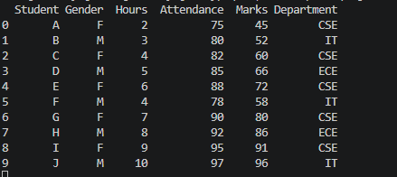

- Line Chart
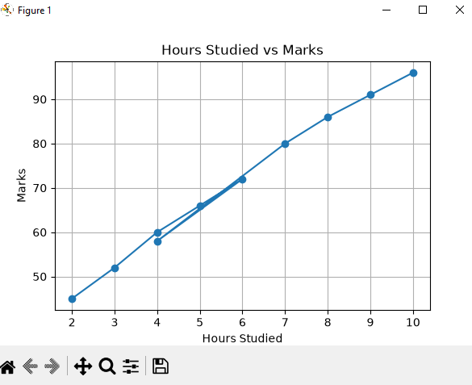
- Bar Chart

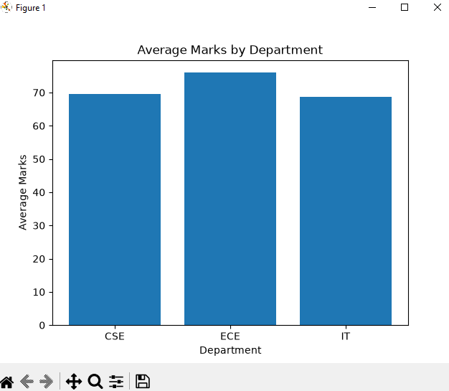
- Histogram
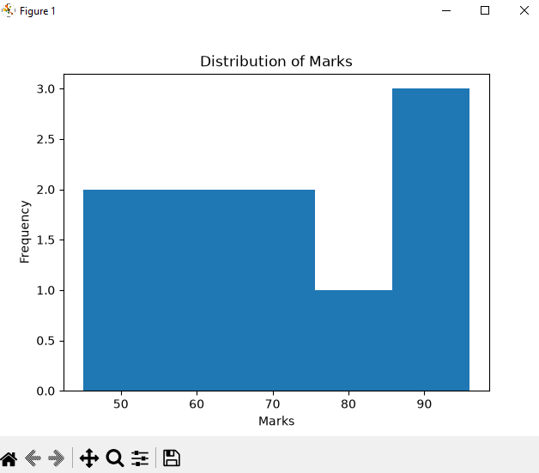

- Scatter Plot
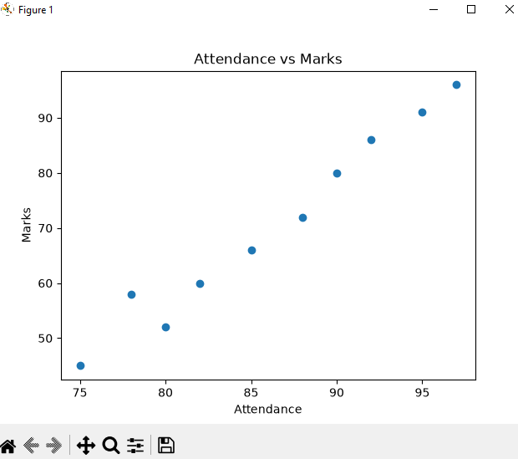

- Pie Chart
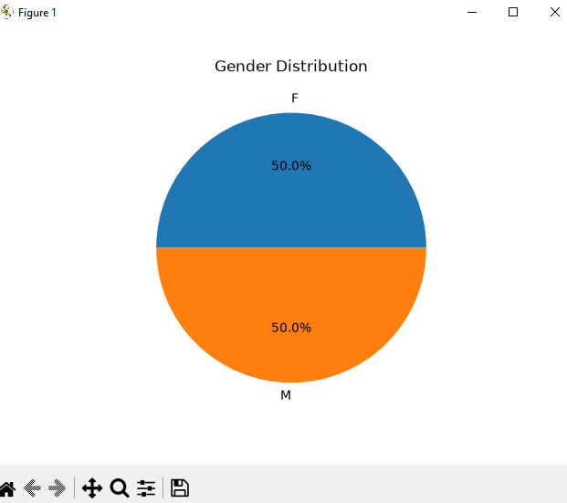

- Box Plot
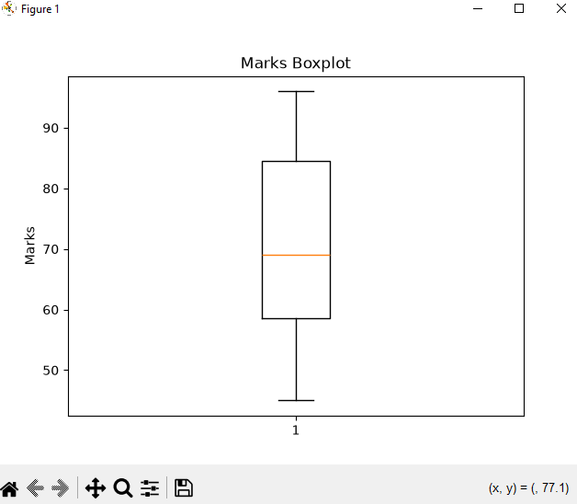

- Area Chart
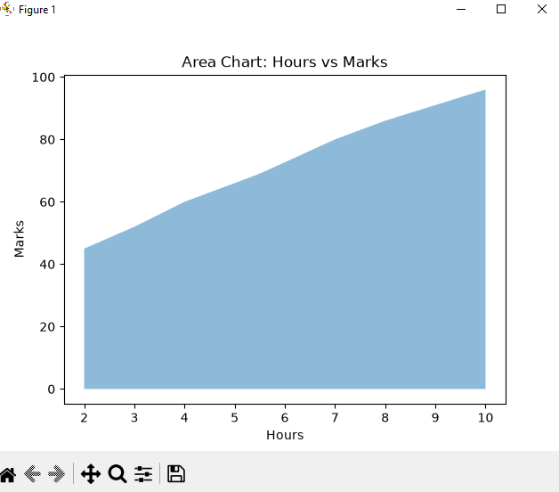

- Horizontal Bar Chart
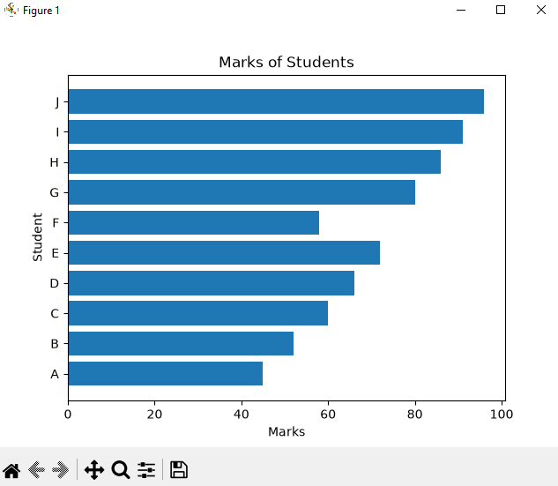

- Multiple Line Chart
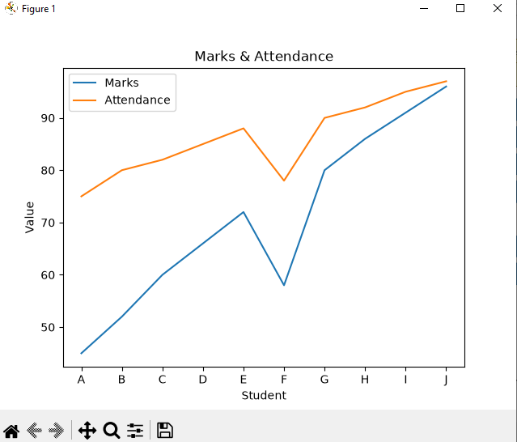

- Stem Plot
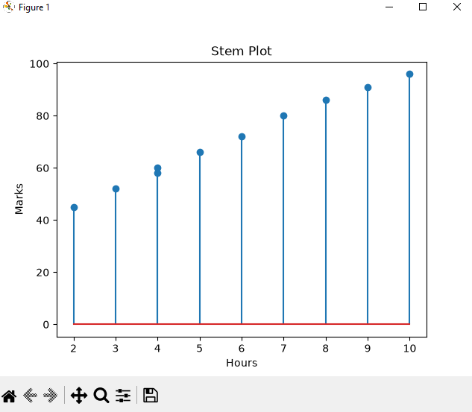

Day 12 – Seaborn & Advanced EDA

1. Task Day & Date
- Day 12
- Date: ____________________

2. Task Description
Today's task was to learn Seaborn, which is a Python library built on top of Matplotlib for statistical charts. I learned about countplot, boxplot, violin plot, heatmap, pairplot, and distribution plots. Using the same retail sales dataset from Day 11, I performed 5 kinds of EDA (Exploratory Data Analysis): distribution analysis, category analysis, outlier analysis, a correlation heatmap, and a pairplot. After creating these, I wrote down what the data was actually telling me, instead of just drawing charts.

3. Task Elaboration

#Day 12
import pandas as pd
import numpy as np
from scipy.stats import binom, norm

data = {
"Student":["A","B","C","D","E","F","G","H","I","J"],
"Gender":["F","M","F","M","F","M","F","M","F","M"],
"Hours":[2,3,4,5,6,4,7,8,9,10],
"Attendance":[75,80,82,85,88,78,90,92,95,97],
"Marks":[45,52,60,66,72,58,80,86,91,96],
"Department":["CSE","IT","CSE","ECE","CSE","IT","CSE","ECE","CSE","IT"]
}

df = pd.DataFrame(data)
df
import seaborn as sns
import matplotlib.pyplot as plt
# 1. Distribution Analysis
sns.histplot(df["Marks"],kde=True)
plt.title("Distribution of Marks")
plt.show()
# 2. Countplot (Category Analysis)
sns.countplot(x="Department",data=df)
plt.title("Students per Department")
plt.show()
# 3. Boxplot (Outlier Analysis)
sns.boxplot(y="Marks",data=df)
plt.title("Marks Boxplot")
plt.show()
# 4. Violin Plot
sns.violinplot(x="Gender",y="Marks",data=df)
plt.title("Marks by Gender")
plt.show()
# 5. Correlation Heatmap
corr = df[["Hours","Attendance","Marks"]].corr()

sns.heatmap(corr,
annot=True,
cmap="coolwarm")
plt.title("Correlation Heatmap")
plt.show()
# 6. Pairplot
sns.pairplot(df[["Hours","Attendance","Marks"]])
plt.show()

5–10 observations
- Marks increase as study hours increase.
- Attendance has a positive relationship with marks.
- CSE contains the largest number of students.
- Female students have slightly higher average marks.
- The marks distribution is approximately normal.
- No major outliers appear in the boxplot.
- Heatmap shows strong positive correlation between Hours and Marks.
- Pairplot confirms a linear relationship among numerical features.
- Students with attendance above 90 mostly scored above 85.
- The dataset is clean with no missing values.

4. Task Screenshot / Proof

- Distribution Analysis

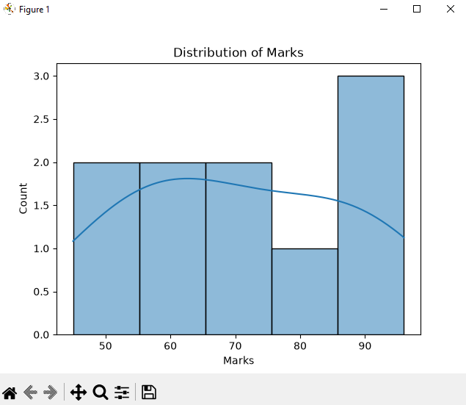

Countplot Category Analysis

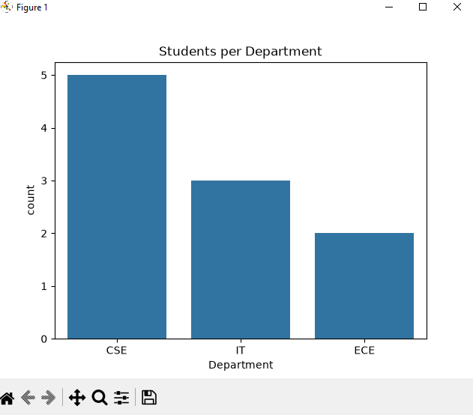

BoxPlot Outlier Analysis

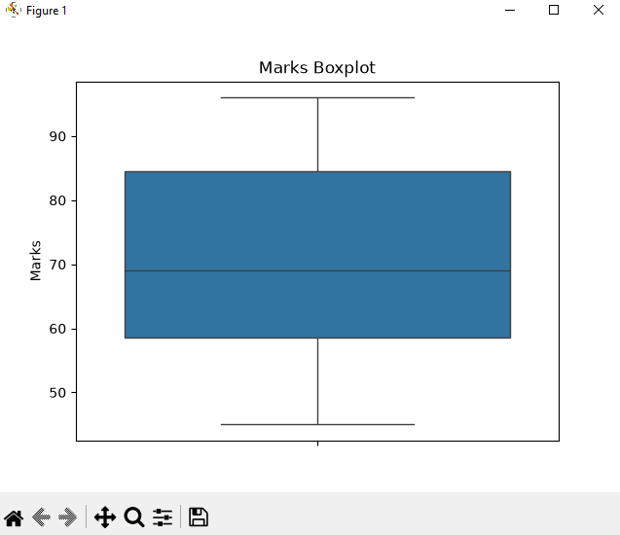

- Violin Plot
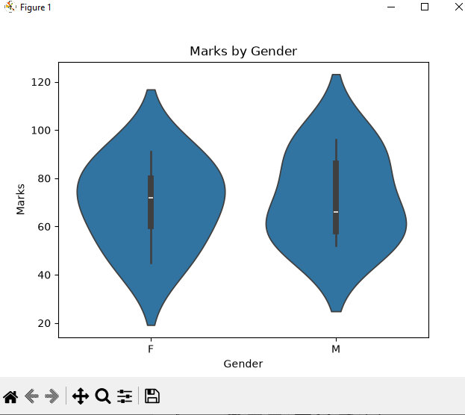

5. Correlation Heatmap

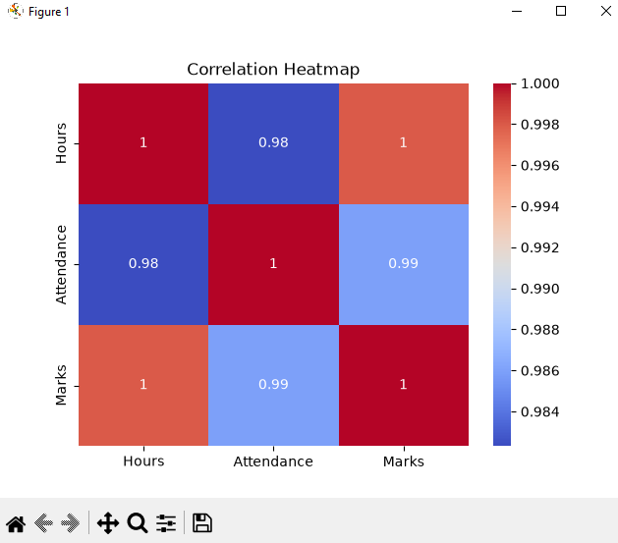

6. Pairplot

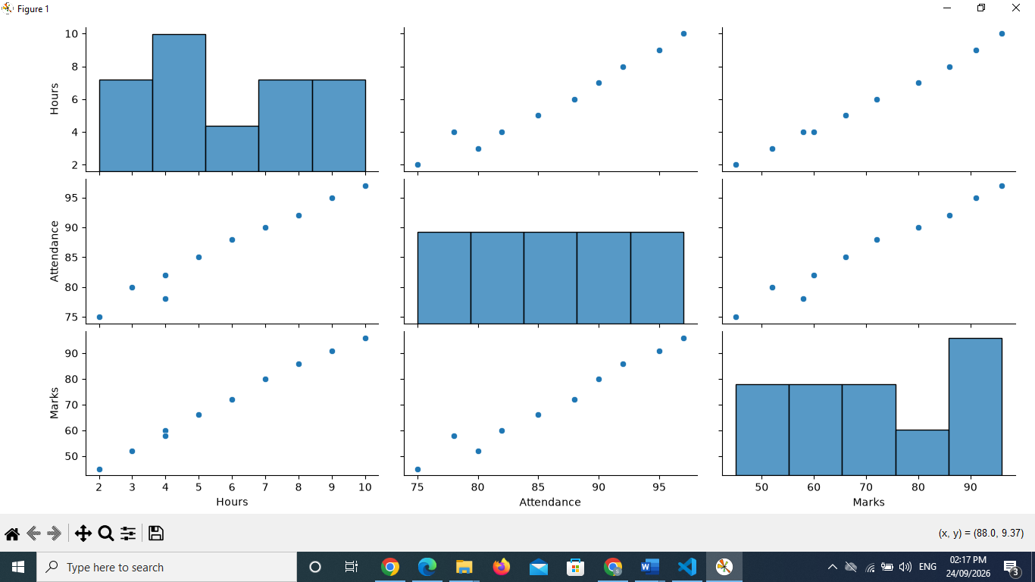

Day 13 – Power BI

1. Task Day & Date
- Day: 13
- Date: __________

2. Task Description
Today's task was to learn Power BI. I learned how to import data, use Power Query to clean and transform it, and work with data types, filters, slicers, charts, cards, tables, and matrix visuals. Using the sales dataset (Order ID, Date, Customer, Region, Category, Sales, and Profit), I built a one-page sales dashboard covering Total Sales, Total Orders, Total Customers, Sales by Category, Sales by Region, and Monthly Sales.

3. Task Elaboration

1. Importing and Transforming the Data
I imported the sales_data Excel file into Power BI and opened Power Query Editor to check the data. I confirmed the data types for each column (Order ID as whole number, Date as date, Sales and Profit as decimal number, Customer/Region/Category as text) and closed and applied the query to load it into the report.

2. Total Sales, Total Orders and Profit Cards
I added three Card visuals at the top of the page: Total Sales (sum of the Sales column), Total Orders (a count of non-blank Order IDs), and Profit (sum of the Profit column), so the key numbers are visible at a glance.

3. Customers Table
I added a Table visual showing the Customer column so every customer in the dataset is listed on the dashboard, giving a quick view of Total Customers alongside the sales figures.

4. Sales by Category (Clustered Bar Chart)
I created a clustered bar chart with Category on the axis and the sum of Sales as the value, sorted in descending order, to compare how each product category is performing.

5. Sales by Region (Pie Chart)
I created a pie chart with Region as the category and the sum of Sales as the value, so the percentage share of sales coming from each region is easy to see.

6. Monthly Sales (Line Chart)
I created a line chart with Date (grouped by month) on the X-axis and the sum of Sales on the Y-axis, to see the sales trend over time.

4. Task Screenshot / Proof

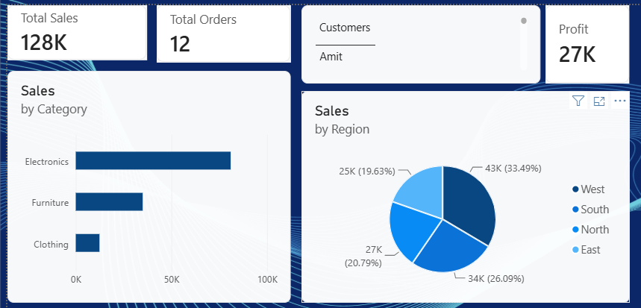
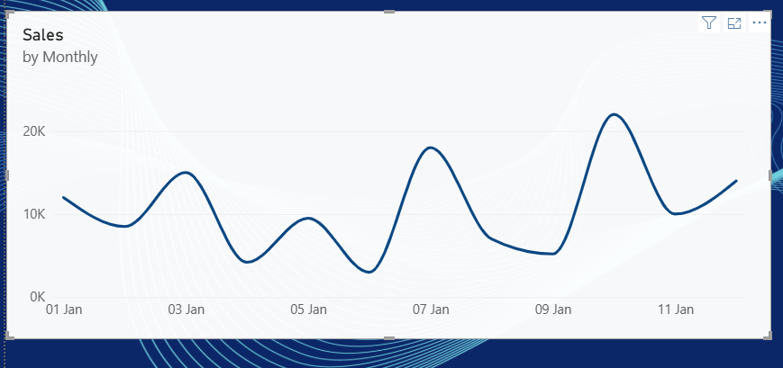

Day 14 – DAX

1. Task Day & Date
- Day: 14
- Date: __________

2. Task Description
Today's task was to learn DAX (Data Analysis Expressions) in Power BI. I created measures for Total Revenue, Total Profit, Total Orders, Total Customers, Average Order Value, and Profit Margin, and then learned CALCULATE, FILTER, ALL, SUMX, COUNTROWS, and DISTINCTCOUNT by writing a few extra measures that use each of them.

3. Task Elaboration

Measures Created
Total Revenue = SUM(Sheet1[Sales])

Total Profit = SUM(Sheet1[Profit])

Total Orders = COUNTROWS(Sheet1)

Total Customers = DISTINCTCOUNT(Sheet1[Customer])

Average Order Value = DIVIDE([Total Revenue], [Total Orders])

Profit Margin = DIVIDE([Total Profit], [Total Revenue])

Total Revenue (SUMX check) = SUMX(Sheet1, Sheet1[Sales])

Sales - North Region (CALCULATE + FILTER) =
CALCULATE([Total Revenue], FILTER(Sheet1, Sheet1[Region] = "North"))

Total Revenue - All Categories (ALL) =
CALCULATE([Total Revenue], ALL(Sheet1[Category]))

What Each Function Does
- CALCULATE: changes the filter context a measure is evaluated in, e.g. forcing Total Revenue to be calculated only for the North region.
- FILTER: builds a filtered version of a table row by row, which I passed into CALCULATE to keep only the rows I wanted.
- ALL: removes filters from a column or table, which I used to get the overall revenue even when a Category slicer is applied.
- SUMX: sums up an expression evaluated for every row of a table, rather than summing an existing column directly.
- COUNTROWS: counts the number of rows in a table, which I used for Total Orders.
- DISTINCTCOUNT: counts the number of unique values in a column, which I used for Total Customers.

4. Task Screenshot / Proof

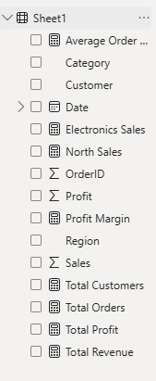

Day 15 – Git & GitHub

1. Task Day & Date
- Day 15
- Date: ____________________

2. Task Description

Today's task was to learn Git and GitHub for version control. I learned about repositories, cloning, and the basic commit-push-pull workflow used to save and sync code. I also studied branching and merging, along with the purpose of a .gitignore file and a README file. As part of the task, I created a GitHub repository named data-internship-[your-username] and uploaded all my work from Day 1 to Day 14 to it.

3. Task Elaboration
- Repository: A storage space on GitHub that holds all the files, folders, and version history of a project.
- Clone: Copying a repository from GitHub to your local system to work on it.
- Commit: Saving a snapshot of changes made to files, along with a message describing the change.
- Push: Uploading local commits to the GitHub repository.
- Pull: Downloading the latest changes from the GitHub repository to your local system.
- Branch: A separate line of development used to work on a feature without affecting the main code.
- Merge: Combining changes from one branch into another.
- .gitignore: A file that tells Git which files or folders to ignore (e.g., temporary files, virtual environments).
- README: A file that describes the project, its purpose, and how to use it — usually the first thing a visitor sees on the repository.

I created the repository data-internship-[your-username], initialized it with a README explaining the internship, and pushed my Day 1–14 work (code files, reports, and dashboards) to it. This repository now serves as my professional portfolio for the internship.

4. Task Screenshot / Proof

Day 16 – Machine Learning Fundamentals

1. Task Day & Date
- Day 16
- Date: ____________________

2. Task Description
Today's task was to understand the basics of Machine Learning. I learned about AI, Machine Learning, Deep Learning, Supervised Learning, Unsupervised Learning, Regression, Classification, and Clustering. Then, for 10 real-world problems, I identified the type of problem, the features, the target, and a possible algorithm to solve it, following the flow: Problem, then Type, then Features, then Target, then Possible Algorithm.

3. Task Elaboration

1. The 10 Real-World Problems
For each problem below, I followed this flow to decide how to solve it: Problem → Type → Features → Target → Possible Algorithm.
Problem 1: Predict the price of a house based on its size, location, and number of rooms.
Step | Answer
Type | Supervised Learning – Regression (the answer is a number)
Features (Inputs) | House size, location, number of rooms, age of the house
Target (Output) | Price of the house
Possible Algorithm | Linear Regression

Problem 2: Classify an incoming email as spam or not spam.
Step | Answer
Type | Supervised Learning – Classification (the answer is a category)
Features (Inputs) | Words used in the email, sender address, number of links
Target (Output) | Spam or Not Spam
Possible Algorithm | Logistic Regression or Naive Bayes

Problem 3: Group customers into segments based on their shopping behaviour, with no existing labels.
Step | Answer
Type | Unsupervised Learning – Clustering
Features (Inputs) | Amount spent, number of visits, days since last purchase
Target (Output) | None (the goal is to find groups, not predict a label)
Possible Algorithm | K-Means Clustering

Problem 4: Predict whether a bank loan applicant will default on their loan.
Step | Answer
Type | Supervised Learning – Classification
Features (Inputs) | Income, credit score, loan amount, employment status
Target (Output) | Default or No Default
Possible Algorithm | Decision Tree or Logistic Regression

Problem 5: Predict how many units of a product will be sold next month.
Step | Answer
Type | Supervised Learning – Regression
Features (Inputs) | Past sales, season, price, ongoing promotions
Target (Output) | Number of units sold next month
Possible Algorithm | Linear Regression or Random Forest Regressor
Problem 6: Detect whether a credit card transaction is fraudulent.
Step | Answer
Type | Supervised Learning – Classification (can also be treated as anomaly detection)
Features (Inputs) | Transaction amount, location, time of day, transaction frequency
Target (Output) | Fraud or Not Fraud
Possible Algorithm | Random Forest or Isolation Forest

Problem 7: Recommend products to a customer based on their browsing and purchase history, with no fixed labels.
Step | Answer
Type | Unsupervised Learning (Recommendation, based on similarity)
Features (Inputs) | Past purchases, items viewed, time spent on each product page
Target (Output) | None (the goal is to find similar items or similar users)
Possible Algorithm | Collaborative Filtering or K-Nearest Neighbours (KNN)

Problem 8: Predict a student's exam score based on study hours and attendance.
Step | Answer
Type | Supervised Learning – Regression
Features (Inputs) | Study hours, attendance percentage, past test scores
Target (Output) | Exam score
Possible Algorithm | Linear Regression

Problem 9: Group a large set of news articles into topics, without knowing the topics in advance.
Step | Answer
Type | Unsupervised Learning – Clustering
Features (Inputs) | Word frequency in each article, key phrases used
Target (Output) | None (the goal is to discover topic groups)
Possible Algorithm | K-Means Clustering or Topic Modelling (LDA)

Problem 10: Classify an image as either a cat or a dog.
Step | Answer
Type | Supervised Learning – Classification (using Deep Learning, since the input is an image)
Features (Inputs) | Pixel values of the image
Target (Output) | Cat or Dog
Possible Algorithm | CNN (Convolutional Neural Network)

